DEEPFAKE DETECTION USING MACHINE LEARNING

## A PROJECT REPORT

|  |  |
| --- | --- |
| ***Submitted by*** | |
| **R. ILAVARASAN** | **(813020205015)** |
| **A. RAJESH** | **(813020205027)** |
| **M. SIVASURIYAN** | **(813020205034)** |
| **S. SURIYA** | **(813020205039)** |

***In partial fulfillment for the award of the degree***

***of***

# BACHELOR OF ENGINEERING

**IN**

**INFORMATION TECHNOLOGY**



**OXFORD ENGINEERING COLLEGE, TRICHY.**

# ANNA UNIVERSITY : CHENNAI 600 025

## MAY 2024

ANNA UNIVERSITY : CHENNAI 600 025

# BONAFIDE CERTIFICATE

Certified that this project report “**DEEPFAKE DETECTION USING MACHINE LEARNING**” is the bonafide work of **“ILAVARASAN .R, RAJESH .A, SIVASURIYAN .M, SURYA .S”** who carried out the project work under my supervision.

##### SIGNATURE SIGNATURE

Mrs. G. Sathya M.E., Mrs. A. Saranya M.E.,

##### HEAD OF THE DEPARTMENT SUPERVISOR

Dept. of Information Technology, **Assistant Professor**

Oxford Engineering College, Dept. of Information Technology,

Trichy-620 009. Oxford Engineering College, Trichy 620 009.

Submitted for the project Viva-Voce Examination held on ……………

## INTERNAL EXAMINER EXTERNAL EXAMINER

**ACKNOWLEDEGEMENT**

This project is successfully completed owing to the comprehensive endurance of many person. It gives great pleasure to recall with a deep sense of gratitude and the moment of beneficialassociation with the guide, friends and others.

I wish to thank our Chairman **Shri. Er. M. SUBRAMANIAM M.E**., Secretary

###### Mrs. S. NIRMALASUBRAMANIAM, Principal Dr. M. KOILRAJ M.Tech., MBA., PhD.,

Head of the Department **Mrs. G. SATHYA M.E**., Information Technology , Oxford Engineering College for their encouragement and support.

I highly indebted to **Mrs. A. SARANYA M.E**., Assistant Professor, Department of Information Technology, Oxford Engineering College for their encouragement and support.

I extend my thanks to all the faculties, non-teaching staffs and friends in the Department of Information Technology and also my parents who helped in successful completion of the project.

At the outset, I wish to express our sincere gratitude to my beloved parents who are solely responsible for the successful completion of the project.

## DECLARATION

I hereby declare that the work entitled “**DEEPFAKE DETECTION USING MACHINE LEARNING**” is submitted in partial fulfillment of the requirement for the reward of the degree in B.E., Anna University, Chennai, is a record of our own work carried out by me during the academic year 2023-2024 under the supervision and guidance of **Mrs.A.SARANYA,M.E., Assistant professor, Department of Information Technology, Oxford Engineering College**. The extent and source of information have derived from the existing literature and have been indicated through the dissertation at the appropriate places. The matter embodied in this work is original and has not been submitted for the award of any degree or diploma, either in this or any other University.

RAJESH A (813020205027)

I certify that the declaration made by above candidate is true.

Mrs.A.SARANYA,M.E.,

Assistant Professor/IT

## DECLARATION

I hereby declare that the work entitled “**DEEPFAKE DETECTION USING MACHINE LEARNING**” is submitted in partial fulfillment of the requirement for the reward of the degree in B.E., Anna University, Chennai, is a record of our own work carried out by me during the academic year 2023-2024 under the supervision and guidance of **Mrs.A.SARANYA,M.E., Assistant professor, Department of Information Technology, Oxford Engineering College**. The extent and source of information have derived from the existing literature and have been indicated through the dissertation at the appropriate places. The matter embodied in this work is original and has not been submitted for the award of any degree or diploma, either in this or any other University.

SIVASURIYAN M (813020205034)

I certify that the declaration made by above candidate is true.

Mrs.A.SARANYA,M.E.,

Assistant Professor/IT

## DECLARATION

I hereby declare that the work entitled “**DEEPFAKE DETECTION USING MACHINE LEARNING**” is submitted in partial fulfillment of the requirement for the reward of the degree in B.E., Anna University, Chennai, is a record of our own work carried out by me during the academic year 2023-2024 under the supervision and guidance of **Mrs.A.SARANYA,M.E., Assistant professor, Department of Information Technology, Oxford Engineering College**. The extent and source of information have derived from the existing literature and have been indicated through the dissertation at the appropriate places. The matter embodied in this work is original and has not been submitted for the award of any degree or diploma, either in this or any other University.

SURYA S (813020205039)

I certify that the declaration made by above candidate is true.

Mrs.A.SARANYA,M.E.,

Assistant Professor/IT

## DECLARATION

I hereby declare that the work entitled “**DEEPFAKE DETECTION USING MACHINE LEARNING** ” is submitted in partial fulfillment of the requirement for the reward of the degree in B.E., Anna University, Chennai, is a record of our own work carried out by me during the academic year 2023-2024 under the supervision and guidance of **Mrs.A.SARANYA,M.E., Assistant professor, Department of Information Technology, Oxford Engineering College**. The extent and source of information have derived from the existing literature and have been indicated through the dissertation at the appropriate places. The matter embodied in this work is original and has not been submitted for the award of any degree or diploma, either in this or any other University.

ILAVARASAN R(813020205015)

I certify that the declaration made by above candidate is true.

Mrs.A.SARANYA,M.E.,

Assistant Professor/IT

# DEEPFAKE DETECTION USING MACHINE LEARNING

**Abstract**

Deepfake detection plays a pivotal role in various applications, demanding accuracy and efficiency. This abstract explores the synergy between two prominent tools: Multi-task Cascaded Convolutional Networks (MTCNN) for robust face detection and InceptionResnetV1 for powerful feature extraction. Deepfake detection is identifying manipulated or synthetic media content using machine learning algorithms and computer vision techniques. It detects anomalies in facial and body movements, and other visual artifacts. we build a Deepfake Detection Engine using the popular Facenet_pytorch is a Python library that provides implementations of deep learning models for face recognition tasks. It includes pre-trained models such as MTCNN (Multi-Task Cascaded Convolutional Networks**)** for face detection and alignment, and InceptionResnetV1 for detecting whether an image is fake or real. The strengths of MTCNN in accurately detecting faces across variations in pose, scale, and occlusion, paving the way for reliable feature extraction. InceptionResnetV1's capability to learn high-level facial features through its inception modules and residual connections, leading to effective discrimination between individuals. We use these two models to detect and recognize faces in images with high accuracy. The library is built on top of PyTorch, a popular open-source machine learning framework, and provides an easy-to-use API for face recognition tasks.

**TABLE OF CONTENTS**

|  |  |  |
| --- | --- | --- |
| **S.NO** | **TITLE** | **PAGE NO** |
|  | **ABSTRACT**  **LIST OF FIGURES**  **LIST OF ABBREVIATIONS** | **VIII**  **XI XII** |
| **1** | **INTRODUCTION**   * 1. Introduction   2. Problem Statement   3. Objectives   4. Methodology   5. Organization | **1**  **1**  **5**  **6**  **6**  **7** |
| **2** | **LITERATURE SURVEY** | **9** |
| **3** | **SYSTEM ANALYSIS**   * 1. Existing System   2. Proposed System | **11**  **11**  **12** |
| **4** | **SYSTEM SPECIFICATION**   * 1. Hardware Requirements   2. Software Requirements | **14**  **14**  **14** |
| **5** | **SOFTWARE DESCRIPTION** | **15** |

|  |  |  |
| --- | --- | --- |
| **6** | **SYSTEM DEVELOPMENT**   * 1. Design   2. Algorithm   3. Model Development   4. System Architecture   5. Data Flow Diagram | **17**  **17**  **18**  **18**  **25**  **26** |
| **7** | **SYSTEM IMPLEMENTATION**   * 1. Evaluation Metrics   2. Results and Analysis | **27**  **27**  **28** |
| **8** | **APPENDICES**   * 1. Source Code   2. Screen Shots | **37**  **39**  **42** |
| **9** | **CONCLUSION & FUTURE ENHANCEMENT**   * 1. Conclusion   2. Future Enhancements | **47**  **47**  **48** |
| **10** | **REFERENCES** | **50** |

**LIST OF FIGURES**

|  |  |  |
| --- | --- | --- |
| **FIGURE NO**  1  2  3  4  5  6  7  8  9 | **FIGURE TITLE**  Deepfake Principle Example of Deepfake System Architecture  Input Sequence through model Data Flow Diagram  Train and Validation Accuracy Train and Validation Loss ResNet50 Architecture  LSTM Architecture | **PAGE NO**  2  3  7  21  26  28  28  37  38 |

**LIST OF ABBREVIATIONS**

|  |  |  |
| --- | --- | --- |
| **S.NO** | **ABBREVIATIONS** | **EXPLANATIONS** |
| 1 | CGI | Computer Generated Imagery |
| 2 | CNN | Convolutional Neural Network |
| 3 | LSTM | Long Short-Term Memory |
| 4 | TL | Transfer Learning |
| 5 | DF | Deep Fake |
| 6 | RNN | Recurrent Neural Networks |
| 7 | DL | Deep Learning |
| 8 | GAN | Generative Adversarial Network |
| 9 | NLTK | Natural Language Toolkit |
| 10 | MTCNN | Multi-Task Cascaded Convolutional Neural Network |
| 11 | ML | Machine Learning |

**CHAPTER-1 INTRODUCTION**

###### Introduction

Technologies for editing images, videos, and audio are advancing rapidly. There has beenan increase in innovation in the areas of changing images, sound recordings, and recordings. A wide range of methods for making and controlling advanced substances is likewise available. Today, it is possible to generate hyper-reasonable advanced pictures with a little asset and a simple how-to guide available on the web. A deepfake is a techniquethat replaces the essence of a particular person in a video with the essence of another. Basically, a single face image gets merged with an integrated portrait. As well as addressing the last result of a promotion reasonable video, the term is also used to refer tothe final product. In addition to creating extraordinary Computer- Generated Imagery (CGI), Virtual Reality(VR), and Augmented Reality(A), Deepfakes can be used for educational purposes, animation, art, and cinema.

As smartphones have become more sophisticated and good internet access has become ubiquitous, an increasing number of social media and media sharing sites have boosted the ability to create and transmit digital videos. Since low-cost computing power has been growing steadily, deep learning has become more powerful than ever before. Advances of this magnitude have inevitably brought new challenges. DeepFake is a manipulation of video and audio using deep generative adversarial models. There are many instances whereDF is spread over social media platforms causing spamming and providing wrong information. Such DFs are terrible and can lead to people's being threatened by, or misledby, them.

The essences of A are reproduced by an auto-encoder EA based on the dataset of facial pictures of A, and an auto-encoder EB is used to reproduce the essences of B from the dataset of facial pictures of B. In order to make Deepfake pictures, you have to assemble adjusted appearances of two changed individuals An and B, then prepare an auto-encoder EA to recreate the essences of A from the dataset of facial pictures of A

encoder EB. Shared encoding loads of EA and EB are used, while keeping the decoding parts of each encoder separate. By improving this coder, any picture with a face of A can be decoded with the decoder of EB, rather than this common encoder. This principle is outlined in Figure 1 and 2.

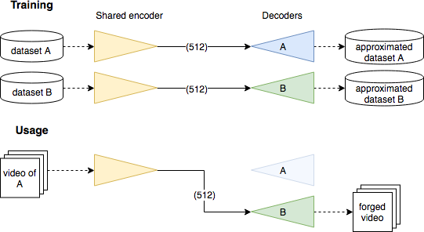

**Figure 1.** *Deepfake principle*.

According to this methodology, an encoder is engaged that concatenates general information of brightening, position, and appearance of the face while a devoted decoder places the detail of each face and recreates steady traits and detail. Using this method, the relevant information can be separated from the morphological information. By and by, the results are great, which explains why the procedure is so significant. The last step consists of taking the objective video, taking the objective face from each frame, adjusting it so that there is the same illumination and expression, then using the modified auto-encoder to produce yet another face, and subsequently merging it with the objective face.

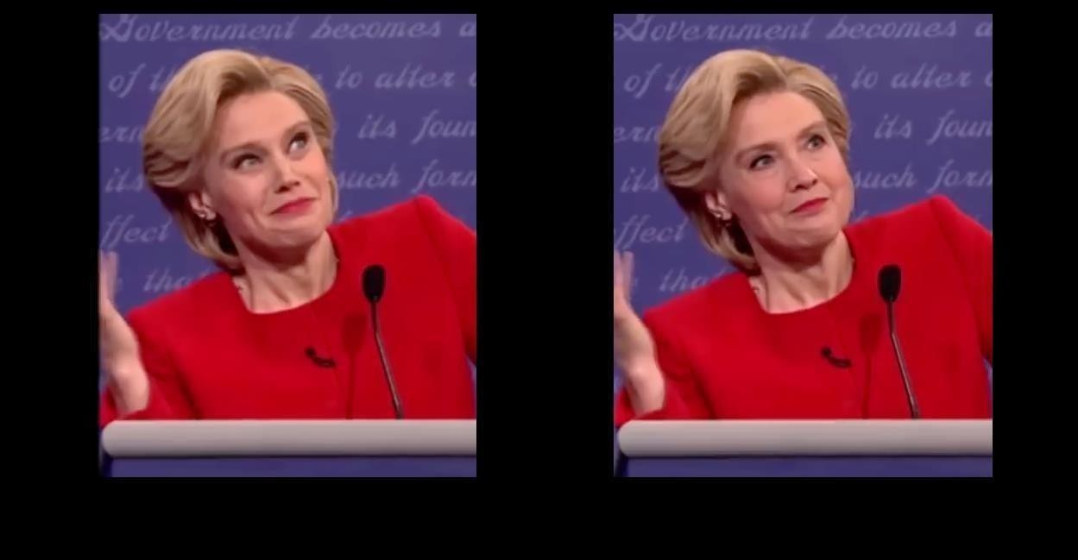

**Figure 2.** Illustration of a picture (left) being manufactured (right) utilizing theDeepfake procedure. Note that the manufactured face comes up short on the expressiveness of the first.

Since the Deepfake peculiarity, different creators have proposed various systems to separate genuine recordings from counterfeit ones. Despite the fact that each proposed system has its solidarity, current discovery techniques need generalizability. As pointed by[1], despite the fact that each proposed system has its solidarity, current discovery techniques need generalizability. The creators noticed that current existing models center around the Deepfake creation apparatuses to handle by concentrating on their alleged practices. For instance, Yuezun *et al*. [2] and TackHyun *et al*. [3] used inconsistencies in eye blinking to detect Deepfakes. However, using the work of Konstantinos *et al*. [4] and Hai *et al*. [5], it is now possible to mimic eye blinking. A system they presented in [4] uses natural facial expressions such as blinking eyes to create videos of talking heads. The authors in [5] proposed a model that can generate facial expression from a portrait. Their framework can blend a still picture to express feelings, including a mind flight of eye- flickering movements. Such progressions in Deepfake innovation make it hard to recognize the controlled recordings. To conquer such a situation, DF recognition is vital.

Thus, we portray another profound learning-based strategy that can viably recognize AI- created fake videos (DF Videos) from genuine recordings. To provide a CNN model to accurately identify and label deepfake videos. Using semi-supervised learning, we present a methodology that is even more accurate than CNN based on the accuracy metric. A subset of DeepFake Detection Challenge data was used to evaluate the proposed ResNetV1 + LSTM model. It was impossible to train on the original dataset since it had many features. So, a subset of the dataset has been taken but the same data and splits as the overall dataset has been maintained.

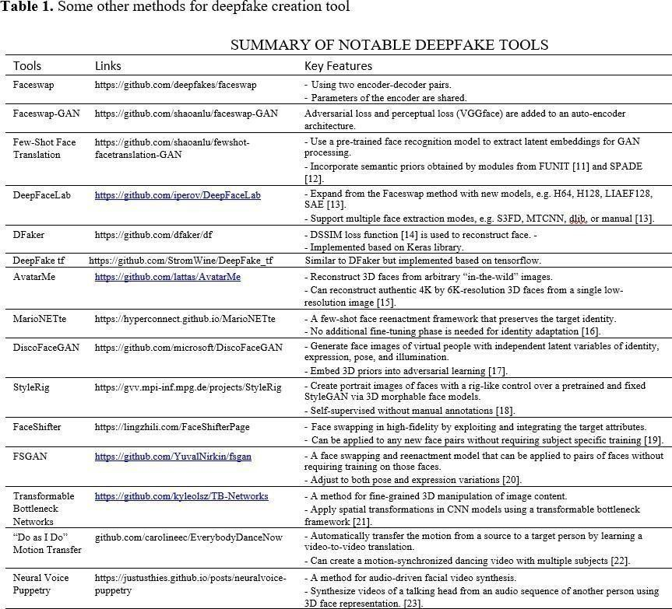

###### Problem Statement

The task is to design and develop a deep learning algorithm to classify the video as deepfake or pristine. We will predict the probability that the video is fake or not with DF detection, which is usually a binary classification where the input is a video

.mp4 and the output is a label L E ["REAL", "FAKE"], and we will be analyzing the input video.

An image classification problem to detect deepfakes can be thought of as a binary image classification task, with input being a video of 150 frames with a resolution of 1920x1080 pixels (or 1080x2040 if recorded vertically). The output can be described as a binary labelV * [0, 1] that indicates the presence or absence of DF videos.

On every sample of the training set, the binary cross entropy loss is optimized.

B 𝐿 (V, l) = −1 ∗ log 𝑝 (Y = 1|V) − (1 − l) ∗ log 𝑝 (Y = 0|V)

The probability that i will be labeled by the network is given by p(Y = i|V).

###### Objectives

Project objectives include the development of a CNN model that accurately detects and labels deepfakes. As a result of this work, we demonstrate that the performance of CNN isoutperformed by a semi supervised learning approach. Using a subset of DeepFake Detection Challenge dataset, we evaluate our ResNetV1 + LSTM based model. Due to the large data set, it was not possible to train the original dataset. We have taken a subset of the dataset but kept the same splits and data as the whole dataset.

###### Methodology

Many tools are available to create Deepfake(DF), but there are few tools available to detect it. We anticipate that our approach for detecting DFs will greatly contribute to the prevention of DF percolation over the world wide web. The method we have developed can detect all types of DF, including replacement DF, retrenchment DF, and interpersonal DF.

Our proposed technique (Figure 3) removes visual and fleeting elements from faces by utilizing a blend of a CNN with an RNN. Since all visual controls are situated inside face areas, and countenances are normally present in a little district of the

frames, utilizing an organization that concentrates highlights from the whole frames

6

considered, we center around removing highlights just in locales where a face is available. We split the video into frames. Followed by the face discovery and editing the frames withidentified face. Then, at that point, consolidating the new edited face to make the new video. Then, at that point, we use ResNetV1 CNN model to separate the highlights from the frames of the video, trailed by a LSTM layer for succession handling. Then, at that point, test-time augmentation is performed, and predictions are made. Our methodology is portrayed exhaustively in the accompanying subsections, including a helping and test augmentation approach we remembered for our DFDC accommodation.

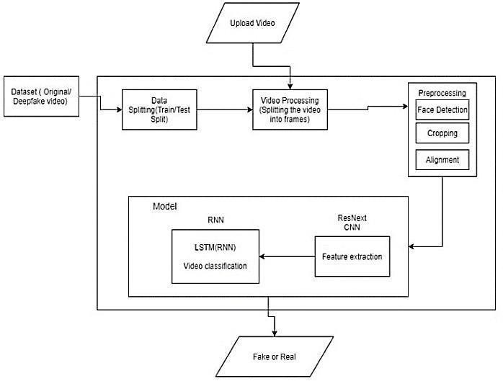

**Figure 3.** System Architecture

###### Organization

This Project is completely based on computer vision. As part of this project, the following methods, technologies and tools are used:

Methods Used:

* + - Data Augmentation
    - Data Visualization
    - Convolutional Neural Networks
    - Transfer Learning
    - ResNetV1
    - MTCNN
    - LSTM
    - Test Time Augmentation

Technologies Used:

* + - Python
    - Pandas, Jupyter Notebook
    - SKlearn
    - Keras
    - Tensorflow

Using any of these technologies is free and do not require any complex technical skills. Because of the time limitations of product development, these technologies are easier to use and faster. Therefore, the project can be implemented with ease.

## CHAPTER-2 LITERATURE SURVEY

Deep fake video is becoming more and more prevalent, posing a serious threat to democracy, justice, and public trust. This has prompted an increase in the demand for video analysis, detectionand intervention. Listed below are a few examples:

* By using a dedicated Convolutional Neural Network model for comparing generated faceswith their surrounding regions, Exposing DF Videos by Detecting Face Warping Artifacts

[6] was able to detect the artifacts. In this work, a pair of facial artifacts are featured. In their method, they observe that current implementations of the DF algorithm can only generate images with limited resolution, which will later need to be transformed further inorder to match the faces in the video source.

* Uncovering AI Created Fake Videos by Detecting Eye Blinking [7] depicts another technique to uncover counterfeit face recordings produced with profound neural organization models. The technique depends on discovery of eye flickering in the recordings, which is a physiological sign that isn't top notch in the orchestrated fake recordings. This technique has been tested over benchmark datasets assessing eye- blinking techniques and demonstrates promising results when applied to recordings created using Deep Neural Network-based programming. Their technique just uses the absence of flickering as a hint for discovery. Anyway certain different parameters should be considered for recognition of the profound fake like teeth charm, wrinkles on faces and so forth Our strategy is proposed to think about this multitude of parameters.
* Capsule network is another method for detecting manipulated or forged video and image data. Through this method, manipulated and forged videos and images can be detected in various situations, like replay attacks and computer-generated videos. There has been random noise used in their method which is an undesirable practice.

Although the model demonstrated positive performance in their dataset, it may not

9

due to noise in training. For training our method, we propose a noiseless and real-time dataset.

* Based on biological signals extracted from genuine and fake portrait video pairs, Detection of Synthetic Portrait Videos [9] detects and identifies fake portrait videos that contain biological signals. To train a probabilistic SVM and a CNN, change the highlight sets andPPG guides to catch the sign attributes, and ensure spatial soundness and transientconsistency. Having determined the likelihood of the video being fake or credible, then a new verification is performed. This program determines whether a product contains counterfeit components with high accuracy, without regard to the generator, the content, the goal, or the nature of the video. It is not convenient to formulate a differentiable loss function based on the proposed signal processing steps when there is a lack of discriminator, resulting in the loss in their findings.
* This technique has been tested over benchmark datasets assessing eye-blinking techniques and demonstrates promising results when applied to recordings created using Deep Neural Network-based programming. Their technique just uses the absence of flickering as a hint for discovery. Anyway certain different parameters should be considered for recognition of the profound fake like teeth charm, wrinkles on faces and so forth Our strategy is proposed to think about this multitude of parameters.
* In this work, a pair of facial artifacts are featured. In their method, they observe that current implementations of the DF algorithm can only generate images with limited resolution, which will later need to be transformed further in order to match the faces in the video source.

10

## CHAPTER - 3 SYSTEM ANALYSIS

###### Existing System

Deepfake detection systems are a constantly evolving field, but they still face some challenges.Here's an example of an existing system with drawbacks:

* **Deep learning-based detection:** This is a prevalent approach that leverages the power of artificial intelligence (AI). Deep learning models are trained on massive datasets of real and fake videos. By analyzing these videos, the models learn to identify subtle patterns and inconsistencies that signal manipulation. For instance, they might detect inconsistencies in facial features, skin texture, lighting, or blinking patterns that can be giveaways of a deepfake.

###### Disadvantages:

* **Evolving deepfakes:** As deepfake creators develop new techniques, detection systems can struggle to keep up. Deepfakes may become so sophisticated that current algorithms miss them entirely. This is especially true for shallow fakes, which are less complex manipulations that can be created more easily and require less processing power. To stay ahead, detection systems need to be adaptable and capable of learning new techniques for spotting deepfakes.
* **Data bias:** The training data can be biased, leading the system to be better at detecting certain types of deepfakes than others. For instance, a system trained mostly on celebrity deepfakes might struggle with detecting fakes of everyday people. This bias can also stem from the way the data is labeled. If the labels are created by humans, they may introduce their own biases into the dataset. To mitigate this, researchers are exploring techniques for creating more balancedand unbiased datasets.
* **Computational cost:** Training and running deep learning models requires significant computing power, making them expensive and resource-intensive to deploy for large-scale

use. This can limit the accessibility of deep detection technology, especially for smaller organizations or individual users. Researchers are working on developing more efficient

fake

11

Deep learning models that can be trained and run on less powerful hardware.

* **Limited scope:** Current deepfake detection systems are often limited to specific types of manipulations, such as facial replacements. They may not be effective at detecting other forms of manipulation, such as audio deepfakes or synthetic media created from scratch. As deepfake technology continues to develop, detection systems will need to be able to cope with a wider range of manipulation techniques.
* **Explainability:** Deep learning models can be complex and opaque, making it difficult to understand why they classify a video as real or fake. This lack of explainability can make it difficult to trust the results of deepfake detection, especially in high-stakes situations. Researchers are working on developing more interpretable deep learning models that can provide explanations for their decisions.

###### Proposed System

* Accurate face detection: MTCNN excels at accurately detecting faces in images and videos, even under challenging conditions like low lighting, occlusion, or variations in pose. This is crucial for deepfake detection, as accurately pinpointing the manipulated region is essential.
* Efficiency: MTCNN is relatively lightweight and computationally efficient compared to other face detection models. This is important for real-time applications where fast processing is needed.
* Pre-trained models: Inception Resnetv1 comes with pre-trained models on large datasets like VGGFace2 and CASIA-Webface, providing a strong starting point for fine-tuning on specificdeepfake detection tasks.
* Flexibility: The model can be adapted for various tasks beyond facial recognition, like anomaly detection and image classification, offering potential for broader applications in deepfake analysis.

###### Advantages:

* End-to-end pipeline: By combining MTCNN for face detection and Inception Resnetv1 for feature extraction, you create a complete deepfake detection pipeline.
* Complementary expertise: MTCNN focuses on the "where" (finding faces), while Inception Resnetv1 focuses on the "what" (analyzing facial features). Together, they provide a comprehensive approach to detection.
* Community support: Both MTCNN and Inception Resnetv1 have active communities with ongoing research and development, ensuring access to updates and improvements.
* Overall, MTCNN and Inception Resnetv1 offer a valuable combination for building robust deepfake detection systems.

## CHAPTER – 4 SYSTEM SPECIFICATION

##### HARDWARE REQUIREMENTS

* Processor : Intel i5 9th gen or AMD Ryzen 5
* RAM : 8 GB
* SSD : 160 GB
* GPU : NVIDIA GeForce GTX 1650 (4 GB)

##### SOFTWARE REQUIREMENTS

* Operating system : Windows OS
* Front End : Gradio
* Back End : Gradio
* IDE : Jupyter Notebook

## CHAPTER – 5 SOFTWARE DESCRIPTION

##### GRADIO :

Interface is Gradio's main high-level class and allows you to create a web-based GUI / demoaround a machine learning model (or any Python function) in a few lines of code. You must specify three parameters: (1) the function to create a GUI for (2) the desired input components and (3) the desired output components. Additional parameters can be used to control the appearance and behavior of the demo.

##### PYTHON :

Python is an interpreted, object-oriented, high-level programming language with dynamic semantics. Its high-level built in data structures, combined with dynamic typing and dynamic binding, make it very attractive for Rapid Application Development, as well as for use as a scripting or glue language to connect existing components together. Python's simple, easy to learn syntax emphasizes readability and therefore reduces the cost of program maintenance. Python supports modules and packages, which encourages program modularity and code reuse. The Python interpreter and the extensive standard library are available in source or binary form without charge for all major platforms and can be freely distributed.

Often, programmers fall in love with Python because of the increased productivity it provides. Since there is no compilation step, the edit-test-debug cycle is incredibly fast. Debugging Python programs is easy: a bug or bad input will never cause a segmentation fault. Instead, when the interpreter discovers an error, it raises an exception. When the program doesn't catch the exception, the interpreter prints a stack trace. A source level debugger allows inspection of local and global variables, evaluation of arbitrary expressions, setting breakpoints, stepping through the code a line at a time, and so on. The debugger is written in Python itself, testifying to Python's introspective power. On the other hand, often the quickest way to debug a program is to add a few print statements to the source: the fast edit-test-debug cycle makes this simple approach very effective.

15

15

##### JUPYTER NOTEBOOK :

Jupyter Notebook is a notebook authoring application, under the Project Jupyter umbrella. Built on the power of the computational notebook format, Jupyter Notebook offers fast, interactive new ways to prototype and explain your code, explore and visualize your data, and share your ideas with others.

Notebooks extend the console-based approach to interactive computing in a qualitatively new direction, providing a web-based application suitable for capturing the whole computation process: developing, documenting, and executing code, as well as communicating the results. The Jupyter notebook combines two components:

A web application: A browser-based editing program for interactive authoring of computational notebooks which provides a fast interactive environment for prototyping and explaining code, exploring and visualizing data, and sharing ideas with others Computational Notebook documents: A shareable document that combines computer code, plain language descriptions, data, rich visualizations like 3D models, charts, mathematics, graphs and figures, and interactive controls.

16

## CHAPTER - 6 SYSTEM DEVELOPMENT

Security, government majority rule, and protection are progressively threatened by deepfakes. Several convincing applications for face trading exist in video compositing, representation changes, as well as character verification as it allows replaced faces in photos with those chosen from a variety of stock photos. But on the other hand, it is additionally a tactic that digital attackersuse to obtain ill-conceived access by infiltration of distinguishing verification frameworks. Forensic modeling can get more challenging using profound learning programs like CNN and GAN because the remaining photos can preserve the pose, facial expression, and lighting of the originals.

GAN images are probably the most difficult to detect among deep learning-generated images since they are highly realistic and high quality thanks to GAN's ability to automatically learn input distributions and generate outputs that have the same distribution as the inputs.

### Design:

The threat of deepfakes has prompted the development of strategies for identifying them. Initially, video synthesis varied in look and complexity to match antique and mechanical elements from antiques. To recognize deepfakes, continuing techniques also applied innovatively developed concepts and strategies to eliminate distinguishable and striking highlights. Location deepfakes are normally classified as binary classification problems, where classification logic is applied to distinguish legitimate recordings from altered ones.

There are three types of deepfake detection methods. Identifying physical and psychological behaviors in videos is the goal of methodologies in the first category. The goal is to track headmovements and eye blinking. We will discuss GAN finger impressions and organic signs found on pictures, such as blood streams that are recognizable in

pictures. In the third category, we consider visual artifacts. For training, visual artifact-

focused methods depend on large amountsof data. It is in this third category that we propose to place the presented model.

17

degradation of frame data after video compression prevents many image detection methods from being used for videos. Aside from that, recordings have worldly attributes that do not adapt among one set of frames, so it is possible to construct strategies that can distinguish juststill photographs from fake ones.

### Algorithm:

* + 1. Start
    2. Upload Deepfake Detection Challenge Image dataset
    3. Importing all necessary Libraries
    4. Data Preprocessing
    5. Build and Train a ResNetV1 + MTCNN Model
    6. ResNetV1 extracts features
    7. MTCNN for face detection
    8. LSTM for sequence processing
    9. Perform Test Time Augmentation
    10. Predict on Test Dataset
    11. End

### Model Development:

#### Dataset: -

Learning from data is at the core of Deep Learning. To achieve good learning quality and accurate predictions, careful dataset preparation is vital. MTCN, YouTube, and Deep fake detection challenge datasets are being used in equal quantities for our mixed dataset. The nature of these recordings commonly incorporates standing or sitting individuals, either confronting the camera or not, with a wide scope of foundations, light conditions, and video quality. The preparation recordings have a goal of 1920 × 1080 pixels, or 1080

× 1920 pixels whenever recorded in vertical mode. This dataset is made by an all-out of 119,146 recordings with an exceptional name (genuine or counterfeit) in a preparation set,

set without names and 4000 private recordings in a testing set. The 4000 recordings of the test set cannot be examined yet models can be assessed on it through the Kaggle framework. The proportion of manipulated: real recordings is 1:0.28. Since just the 119,245 preparing recordings contain names, we utilize the entirety of that dataset to prepare and approve our strategy. The gave preparing recordings are isolated into 50 numbered sections. Our preparation process uses 30 sections, our validating process uses 10 sections, and our testing process uses 10 sections.

The private set utilized for testing assesses submitted strategies inside the Kaggle framework and reports a log-likelihood loss. Log-likelihood loss radically punishes being both sure and wrong. In the most pessimistic scenario, an expectation that a video is bona fide when it is really controlled, or the opposite way around, will add boundlessness to your an interesting name is allotted to every video determining whether or not it contains a control. Notwithstanding, it isn't indicated which sort of control is performed: face, sound, or both. As our technique just uses video data, controlled recordings with just sound controls will prompt boisterous marks as the video will be named as fake however faces will be genuine. Moreover, more than one individual may be available in the video, with face controls performed on just one of them. blunder score. Practically speaking, assuming this most pessimistic scenario occurs, the loss is cut to an extremely huge worth. This assessment framework represents an additional a test, as techniques with great execution in measurements like exactness, could have extremely high log-likelihood blunders. Our recently pre-arranged dataset contains half of the first video and half of the controlled deepfake recordings. The dataset is parted into 80%train and 20% test set.

#### Classification Setup: -

In the following model, X refers to the input set, Y refers to the output set, and f is the prediction function of the classifier that takes values in X as input to the action set A, the random variable pair (X, Y) that is assumed to take values in X * Y. The chosen classificationtask is to minimize the error E(f) = E[l(f(X), Y)], with l(a, y) = 1/2 (a − y) ^2

.

PyTorch and Keras 2.1.5 have been used to implement both networks using Python 3.5. The network's weights are optimized using successive batches of frames of size 224 × 224

× 3 usingthe default parameters for ADAM (β1 = 0.9 and β2 = 0.999).

#### Preprocessing: -

The video is divided into frames as part of the pre-processing. Then, face recognition is performed, followed by trimming of the frames that contain the detected faces. We determine the mean of the dataset video and make a new handled face trimmed dataset containing the frames equivalent to the mean in order to maintain consistency in the quantity of frames. In pre-processing, frames without faces are ignored. Since all visual controls are situated inside face areas, and countenances are ordinarily present in a little locale of the casing, utilizing an organization that concentrates highlights from the whole frames isn't great. All things being equal, we center around extricating highlights just in districts where a face is available. As handling the 10 second video at 30 frames each second for example all out 300 frames will require a ton of computational power. So we propose to use only 150 frames for training the model for experimental purposes.

#### Model: -

In deepfake videos, there are inconsistencies between frames as well as within frames. LSTM and CNN are used to identify deepfake recordings using the temporal-aware pipeline technique. CNN is utilized to eliminate frame-level elements, which are subsequently incorporated into LSTM to make a succession descriptor. The model comprises of ResNetV1followed by one LSTM layer. A fully connected network is at last utilized for grouping doctored recordings from genuine ones dependent on the succession descriptor. The Data Loader stacks the pre-handled face trimmed recordings and split the recordings into train and test set. Further the frames from the handled recordings are passed to the model for preparing and testing in mini batches. The recognition network comprising of fully connected layers is

utilized to accept the grouping descriptor as information and work out probabilities of the frames arrangement having a place with either bona fide or deepfake class.

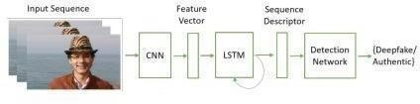

**Figure 4.** Input Sequence through model

#### ResNet CNN for Feature Extraction: -

By using the ResNet CNN classifier, we are proposing to efficiently extract the features and create an accurate frame level classifier instead of rewrite it. To properly converge the gradientdescent of the model, we will add extra layers and choose a proper learning rate to fine-tune the network. After the last pooling layer, the 2048-dimensional feature vectors are used as thesequential LSTM input.

#### MTCNN for Face Detection : -

Multi-task Cascaded Convolutional Networks (MTCNN) is a framework developed as a solution for both face detection and face alignment. The process consists of three stages of convolutional networks that are able to recognize faces and landmark location such as eyes, nose, and mouth.

The MTCNN as a way to integrate both tasks (recognition and alignment) using multi- task learning. In the first stage it uses a shallow CNN to quickly produce candidate windows. In the second stage it refines the proposed candidate windows through a more complex CNN. And lastly, in the third stage it uses a third CNN, more complex than the others, to further refine the result and output facial landmark positions.

MTCNN (Multi-task Cascaded Convolutional Neural Network) is a powerful detector that finds faces in an image, using a cascade of three smaller neural networks to progressively refine its detection for accuracy and efficiency across various face sizes, orientations, and lighting conditions.

It can also detect key facial landmarks like eyes, nose, and mouth. Once MTCNN locates faces, ResNetv1 (Residual Network Version 1), a convolutional neural network architecture known for its image classification capabilities, comes into play. ResNetv1 takes the face image (cropped and aligned based on MTCNN's landmarks) and extracts a facial feature embedding, a compressed vector representation that captures the unique facial characteristics of the person in the image.

By combining these two models, you achieve a robust face recognition pipeline: MTCNN ensures accurate face detection even in challenging scenarios, and ResNetv1 then uses the well-aligned face to generate a distinctive embedding for recognition tasks like face verification (comparing a face to a known identity) or identification (finding the identity of an unknown face in a database).

#### LSTM for Sequence Processing: -

Data from all tested casings should be used to perform the video-level forecast. In addition to the programmed face weighting, we incorporate a Recurrent Neural Network (RNN) underneath to combine the highlights of all face districts and frames. In order to get an accurate measurement, we combine the features, logits, and all face districts with the Long Short-TermMemory (LSTM). We expect a progression of ResNet CNN data frames graphs as informationand a two-hub neural organization, with chances for the combo to be imperative for an extensive fake video or an untampered video. Developing a model to recursively process sequences in a meaningful manner is the key challenge to be addressed. As a solution, we

propose the use of a 2048 LSTM unit with 0.4 dropout probability, in order to accomplish ourobjectives.

By comparing the frame at 't' second with the frame at 't-n' second, the time of the video can be analyzed by using LSTMs. In other words, n is the number of frames before The LSTM consists of three stacked bidirectional layers and one unidirectional layer with aspect 2048. Todetermine the likelihood of the video being manipulated, the direct layer and the Sigmoid function are applied to the result of the LSTM.

#### Training Process: -

Training, validation, and testing are essential components of Deepfake detection. Training forms the core of the proposed model. This is where learning takes place. For DL models to fitspecific domains of problems, designs and fine-tuning are necessary. We must find parameters that are optimal for training our dataset. The training and validation components are also similar. During the validation process, we fine-tune our model. The validation component tracks progress in training and accuracy in detecting DeepFakes. A specific video is classified and determined by the testing component by determining the class of the faces extracted. Thetesting component contributes to the research objectives.

Feature Learning (FL) is one component of the proposed model, while classification is the other. FL extracts learnable features from face images by analyzing them. As input, the FL is converted into a sequence of pixels for the final detection process through the Classification process. A feature learning (FL) method involves convolutional operations that are stacked on top of each other. A ResNetV1-inspired architecture underlies the feature learning component. As opposed to the ResNetV1 architecture, the FL component does not have the fully connected layer, and its purpose is not to classify faces but rather to extract features fromface images for the Classification component. As a result, with a FL component, you do not have the fully connected layer of a CNN.

The ResNetV1 is initialized with pre-trained weights. We introduce the LSTM and Fully Connected layers with an arbitrary weight system. The network is prepared start to finish with the parallel cross-entropy loss (BCE) work with the LSTM expectation. The BCE loss is processed with trimmed countenances from casings of a haphazardly chosen video. Note that this loss depends on the result probabilities of recordings being controlled (video level forecast). The BCE applied to refreshes the loads. The BCE applied to refreshes all weights ofthe outfit (barring ResNetV1).

C:\Users\HP\Downloads\df3.JPG

While we train the total group start to finish, we start the training process with a discretionaryintroductory advance comprising of 2000 batches of arbitrary harvests to get an underlying arrangement of parameters of the model. While this didn't present any expansion in discovery precision during our trials, it gave a quicker union and a more steady preparing process.

Because of computational limitations of GPUs, the size of the network, and the quantity of info frames, just a single video can be handled at an at once. Be that as it may, the network parameters are refreshed in the wake of handling each 64 recordings (for the binary cross- entropy loss). With a learning rate of 0.001, Adam is used as the optimization technique. Our method for reducing calculation costs uses Relu (activation function) and LeakyRelu.

The BCE loss is processed with trimmed countenances from casings of a haphazardly chosen video. Note that this loss depends on the result probabilities of recordings being controlled (video level forecast). The BCE applied to refreshes the loads. The BCE applied to refreshes all weights ofthe outfit (barring ResNetV1).

#### Evaluation: -

The model is arranged using the twofold cross-entropy loss function. A min-batch of 32 pictures are normalized using mean of [0.485, 0.456, 0.406] and standard deviation of [0.229, 0.224, 0.225]. The standardized face pictures are then increased prior to being taken care of into the model at each preparation cycles. Adam analyzer with a learning pace of 0.1e-3 and weight rot of 0.1e-6 is utilized for enhancement. The model is prepared for an aggregate of 20epochs. The classification procedure takes in 30 facial pictures and passes it to our prepared model. To decide the characterization exactness of our model, we utilized a log loss function. A log loss depicted in Equation 1 groups the organization into a likelihood circulation from 0 to 1, where 0 > y < 0.5 addresses the genuine class, and 0.5 ≥ y < 1 addresses the fake class. We picked a log loss classification metric since it profoundly punishes irregular suppositions and confident false forecasts.



**Figure** System Architecture

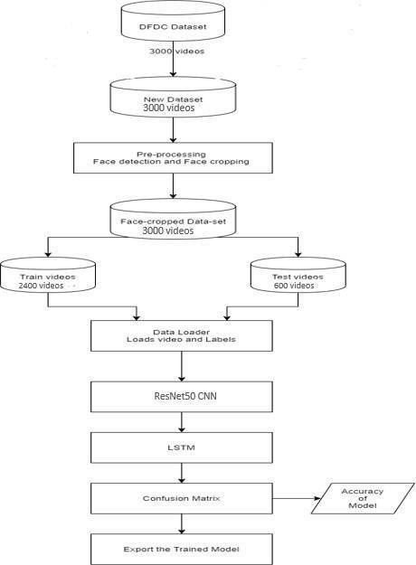

**Figure 5.** Data Flow Diagram

## CHAPTER - 7 SYSTEM IMPLEMENTATION

###### Evaluation Metrics

As a result of deepfakes, you can open up additional opportunities in computerized media, virtual reality, mechanics, education, and numerous other fields. In another context, they represent innovations that can ruin and undermine the whole society. With this in mind, we developed a model that combines CNNs and LSTMs for the DF video identification task.

LSTMs can deal with sequences of consecutive frames, whereas CNNs are good at learning local highlights. Our model leverages this combined limit to associate each pixel in a picture and comprehend nonlocal highlights. When preparing and grouping, we gave equal emphasis to the preprocessing of the information.

The networks have been analyzed to find out how they approach classification. We can do thisby using the weights of the diverse convolutional kernels and neurons as descriptors of pictures. Inferences can be deciphered as discrete second requests, for example, by using a positive weight, a negative one, and a positive weight once again. Although this is just an indication of the main layer, it doesn't convey much during appearances. To find out what sort of sign is being received by a particular channel [6] another way is to generate an informationpicture amplifying the initiation of that channel. As shown in the below Figure, the last secret layer of ResNetV1 has been actuated to such a great extent for a very long time. Based on theweight assigned to their result for the last arrangement choice, depending on whether their actuation pushes toward a negative or positive score, we can isolate those neurons that influence either the genuine or produced class. In significant contrast, positive-weighted neurons induction exhibited photos with exceptionally clear eye, nose, and mouth areas as opposed to negative-weighted neurons, which contained “differences” on the establishment portion, leaving the face area “smooth.” As Deepfake-made faces are typically blurry, or else somewhat opaque, if not

for the emphasis on nuances, are displayed differently to the remainder of the photograph that is left unchanged. The underlying result of a layer can at thesame time be viewed as a mean aftereffect for gatherings of certified and fabricated images,

27

and the distinctions among the incitements can be seen as well and perceptibly interpreted as the information photographs that are significant to the course of action. Since the establishment displays the most important apexes on authentic pictures anyway, the eyes are clearly started on authentic pictures. It is apparent to us that it is again a question of fogginess: In genuine pictures, however, the eye is the most definite element while in synthetic pictures, the eye is the primary piece due to the aspect reduction experienced by the face.

###### Results and Analysis

Using the combination of Conv+LSTMs and test-time augmentation, we apply Transfer Learning to pre-trained models such as ResNetV1, MesoNet and DenseNet121. The DFDC dataset helps us prepare and evaluate our strategy. Our comparison shows that our approach is relatively superior to the other three approaches. When these networks are considered, we can simply normalize the expectations for each frame to calculate a forecast on video level. With the guidance of the validation set, the arrangement that yields the best adjusted precision is determined. Based on balanced accuracy, Table 1 shows the results. If we process only the faceregions, the accuracy increases dramatically. Almost all pre-trained models were overfit after six to eight epochs, as illustrated in Figure 3, the loss of the train sets and validation sets for the ResNet+LSTM model is shown. The validation loss begins to increase after the 5th epoch, which indicates overfitting. Testing was enhanced using test-time augmentation (TTA). With TTA, you can perform data augmentation on a test image to get several versions of it and average predictions. Our evaluation of TTA used a different set of transformations .

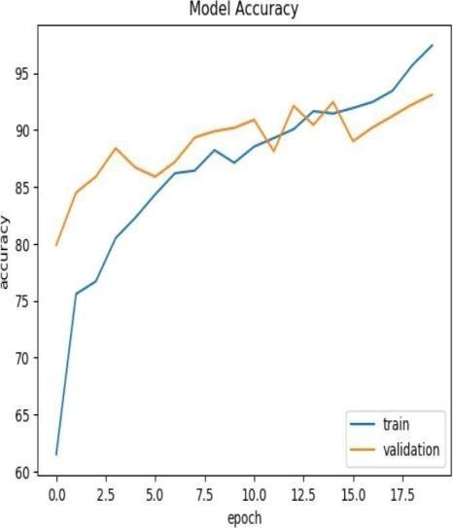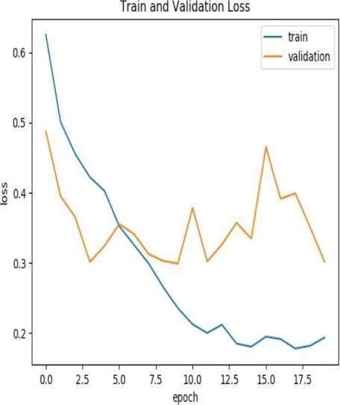

**Figure 6.** Train and Validation Accuracy **Figure 7.** Train and Validation

**Screen shots of the various stages of the ProjectImporting Packages –**

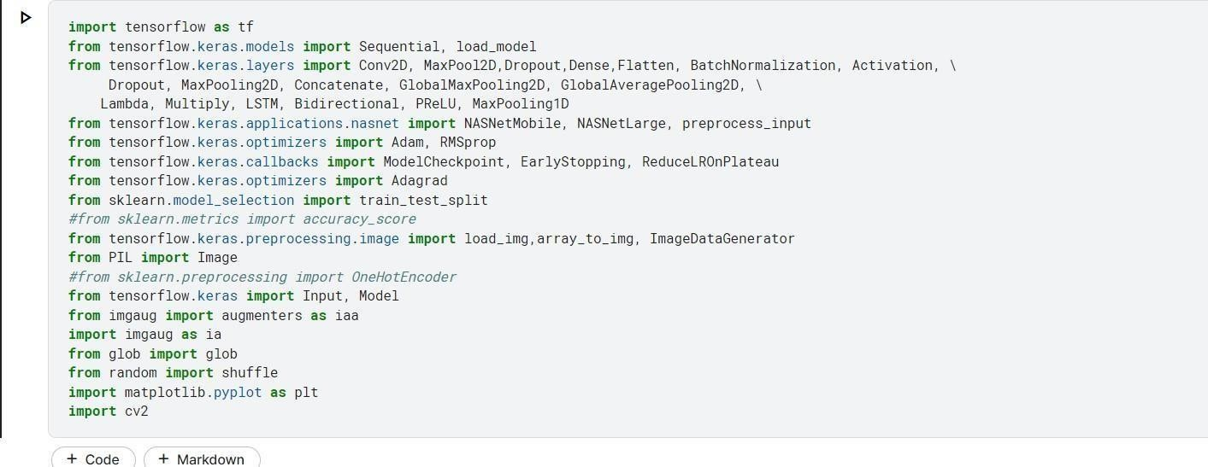

**Pre-Processing –**

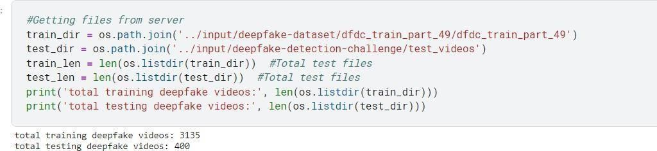

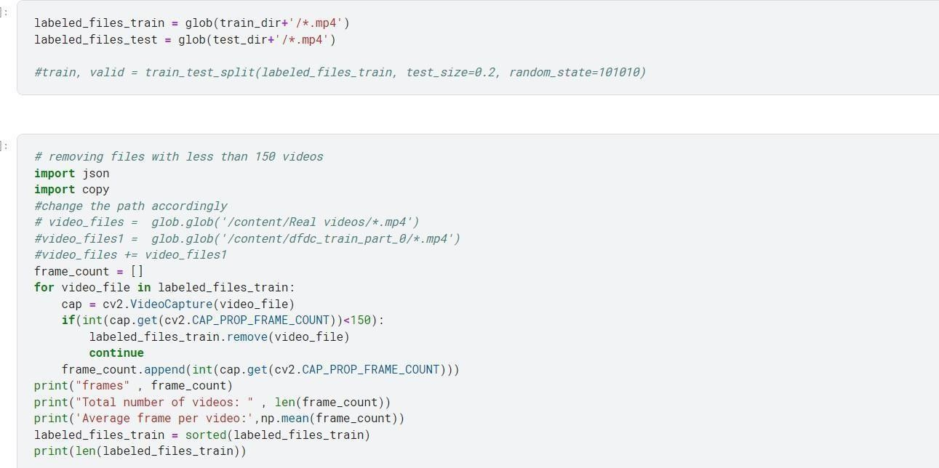

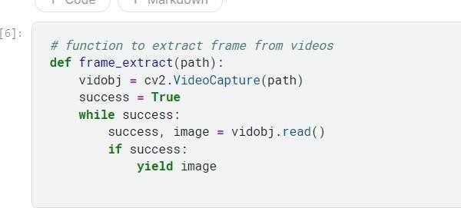

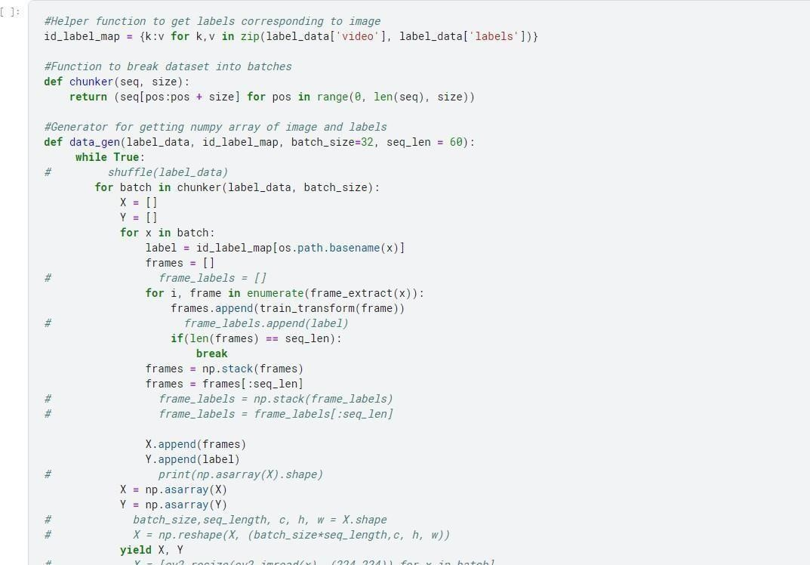

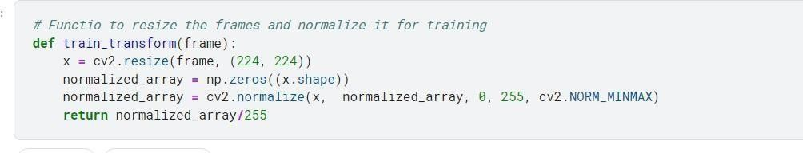

**Model Architecture –**

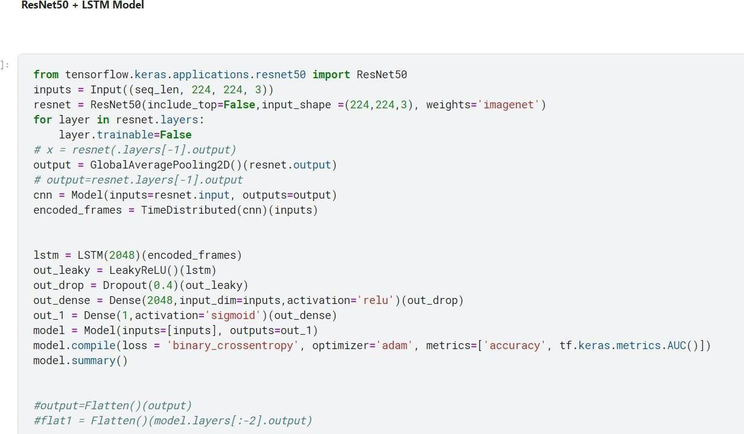

**Training Model -**

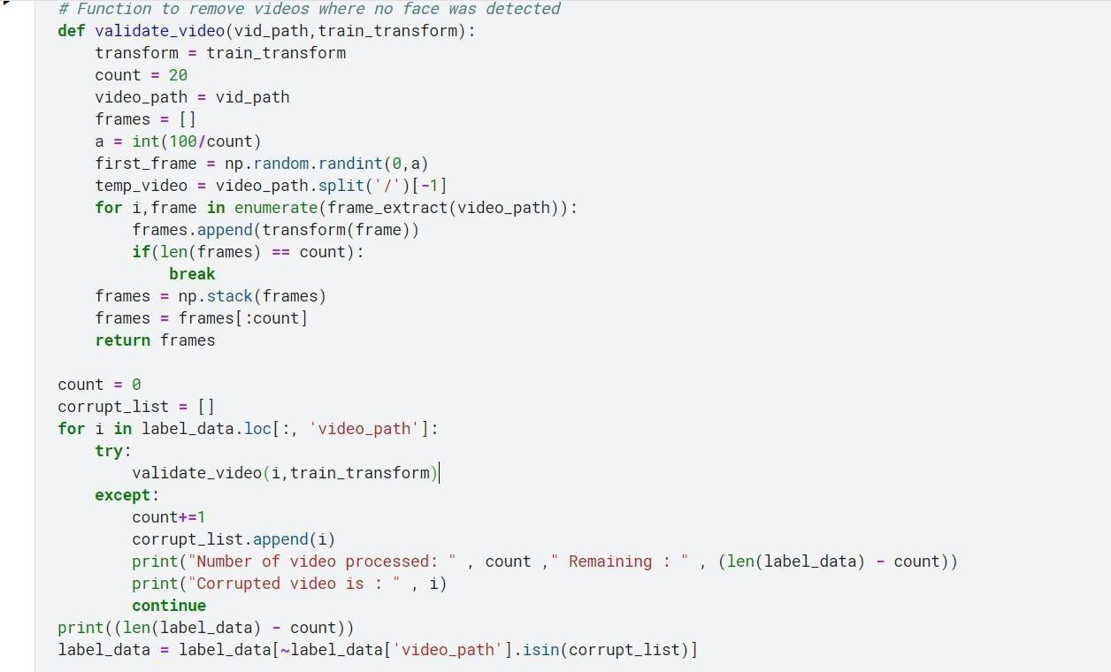

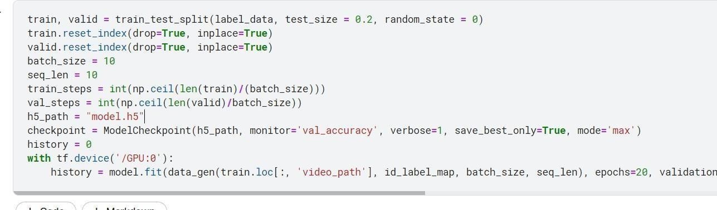

**Model Accuracy & Loss –**

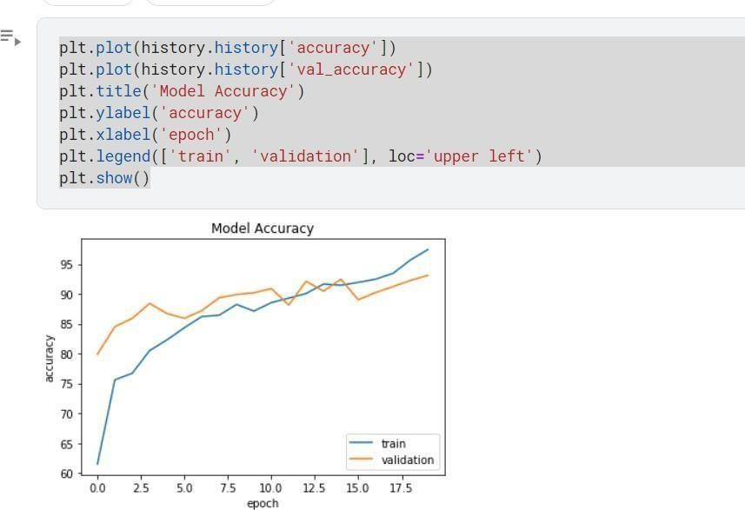

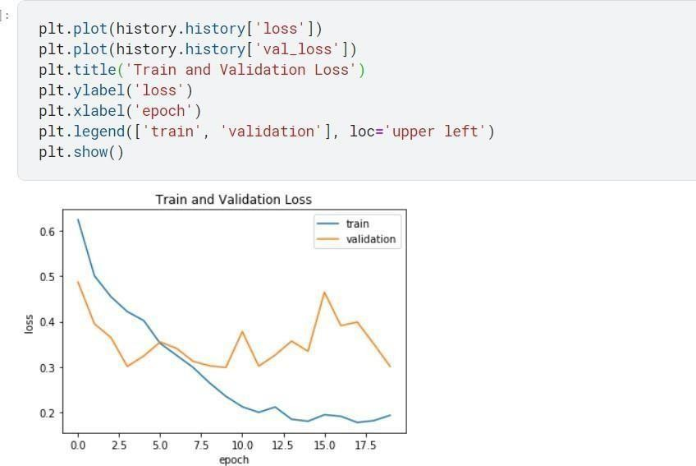

* 1. **Comparisons**

Our dataset was used to train multiple models. From those, ResNetV1 + MTCNN offers the most accurate testing and training results. Our observations have shown that the network regularly fails to engage in exceptionally practical and effective manipulation based on poorly lit or foggy images that are inferior in quality. Despite their difficulty, manipulations made in excellent recordings appear to be accurately identified.

**Table 2.** Evaluation Results

|  |  |  |
| --- | --- | --- |
| ***Model*** | ***Train Data*** | ***Test Data*** |
| *Custom Model* | 0.8523 | 0.8057 |
| ***ResNetV1+MTCNN*** | **0.9795** | **0.9463** |
| *MesoNet* | 0.9568 | 0.8997 |
| *DenseNet121* | 0.9699 | 0.9181 |

**CHAPTER - 8**

## APPENDICES

###### ResNetV1 Structure: -

The advantage of using residual networks is that they can skip blocks of convolutional layers by using shortcut connections. In this architecture, the down-sampling process occurs at convolutionallayers with stride of two, after which batch normalization is performed. In the final stage of the process, a ReLU activation is applied. The architecture consists of 101 layers in total, ending with a softmax activation at the top. Five stages comprise ResNet-50, each including convolution and identity blocks. Within each convolution block and within each identity block, there are 3 convolution layers. Over 23 million parameters can be trained with the ResNet-50.

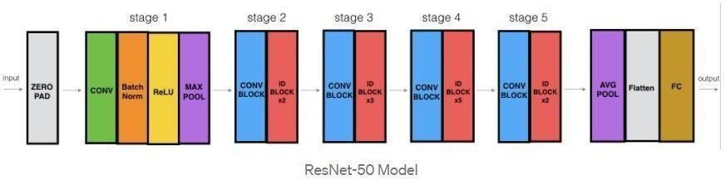

**Figure 8.** ResNetV1 Model Structure

###### LSTM Layer: -

A LSTM network is a type of recurrent neural network that is capable of learning order dependence in sequence prediction problems. The purpose of such behavior is to simplify complex problem spaces such as machine interpretation and speech processing. LSTMS are a complex aspect of deep learning. In order to gain a clear understanding of LSTMs and how terms like bidirectional and sequential go together, it is sometimes difficult to grasp their significance.

Significantly, LSTM is similar to a RNN cell. LSTM's inner workings can be viewed here. Here is the inside working of the LSTM organization. In the picture below, you can see that the LSTMconsists of three sections, each of which fulfills a specific function.

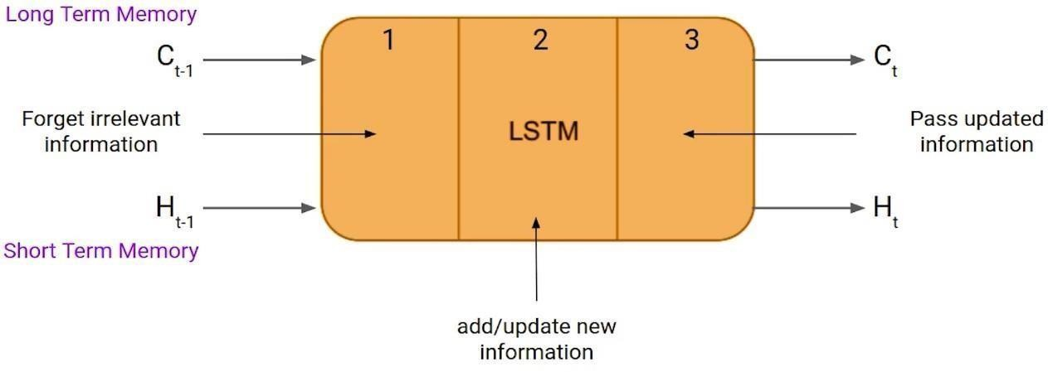

**Figure 9.** LSTM Architecture

Based on the timestamp of the past, the initial segment decides if the data from that time should be recalled or not. Cellular integration takes place in the following part when the new data is assimilated into this cell. Finally, in the third part, the cell passes the refreshed data from the currenttimestamp to the following timestamp.

LSTM cells consist of three pieces known as entryways. First there is the Forget door, then the Input entryway, and last but not least, the Output entryway. Similar to an RNN, an LSTM also has a secret state, where H(t-1) addresses the current timestamp's secret state and Ht addresses the pasttimestamp's secret state. LSTMs have an additional cell state addressed by C(t-1) and C(t) on their own, depending on whether they are addressing past or present timestamps.

Cell's state is called short term memory, and the secret's state is called Long term memory. In lightof this, it's interesting to observe that the cell state is what contains all the timestamps.

## SOURCE CODE

import gradio as grimport torch

import torch.nn.functional as F

from facenet_pytorch import MTCNN, InceptionResnetV1import numpy as np

from PIL import Image import cv2

from cv2 import VideoCapture

from pytorch_grad_cam import GradCAM

from pytorch_grad_cam.utils.model_targets import ClassifierOutputTargetfrom pytorch_grad_cam.utils.image import show_cam_on_image

import warnings warnings.filterwarnings("ignore")

DEVICE = 'cuda:0' if torch.cuda.is_available() else 'cpu'mtcnn = MTCNN(

select_largest=False, post_process=False, device=DEVICE

).to(DEVICE).eval()

model = InceptionResnetV1( pretrained="vggface2", classify=True, num_classes=1, device=DEVICE

)

checkpoint = torch.load("resnetinceptionv1_epoch_32.pth", map_location=torch.device('cpu')) model.load_state_dict(checkpoint['model_state_dict']) model.to(DEVICE)

model.eval()

video = cv2.VideoCapture

def predict(input_image:Image.Image): """Predict the label of the input_image""" face = mtcnn(input_image)

def predict(input_video,additional_arg):

"""Predicts labels for each frame in a video using the 'predict' functionand displays a sample frame with the label.

Args:

video_path: Path to the input video file.

additional_arg: Any additional argument required by the predictfunction.

Returns:

None"""

face = mtcnn(input_video)if face is None:

raise Exception('No face detected')

face = face.unsqueeze(0) # add the batch dimension

face = F.interpolate(face, size=(256, 256), mode='bilinear', align_corners=False)

# convert the face into a numpy array to be able to plot itprev_face = face.squeeze(0).permute(1, 2,

0).cpu().detach().int().numpy() prev_face = prev_face.astype('uint8')

face = face.to(DEVICE) face = face.to(torch.float32) face = face / 255.0

face_image_to_plot = face.squeeze(0).permute(1, 2, 0).cpu().detach().int().numpy()

target_layers=[model.block8.branch1[-1]]

use_cuda = True if torch.cuda.is_available() else False

cam = GradCAM(model=model, target_layers=target_layers, use_cuda=use_cuda)

targets = [ClassifierOutputTarget(0)]

grayscale_cam = cam(input_tensor=face, targets=targets,

eigen_smooth=True)

grayscale_cam = grayscale_cam[0, :]

visualization = show_cam_on_image(face_image_to_plot, grayscale_cam, use_rgb=True)

face_with_mask = cv2.addWeighted(prev_face, 1, visualization, 0.5, 0)

with torch.no_grad():

output = torch.sigmoid(model(face).squeeze(0)) prediction = "real" if output.item() < 0.5 else "fake"

real_prediction = 1 - output.item() fake_prediction = output.item()

confidences = {

'real': real_prediction, 'fake': fake_prediction

}

return confidences, face_with_mask

interface = gr.Interface( fn=predict,

inputs=[

gr.inputs.Image(label="Input Image", type="pil"), gr.inputs.Video(label="Input Video", type="cv2")

],

outputs=[

gr.outputs.Label(label="Class"),

gr.outputs.Image(label="Face with Explainability", type="pil")

],

).launch()

* 1. 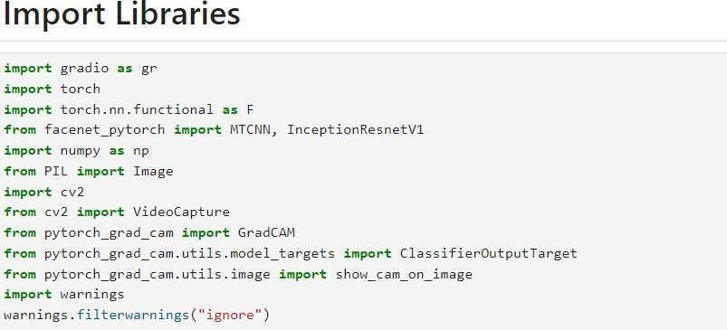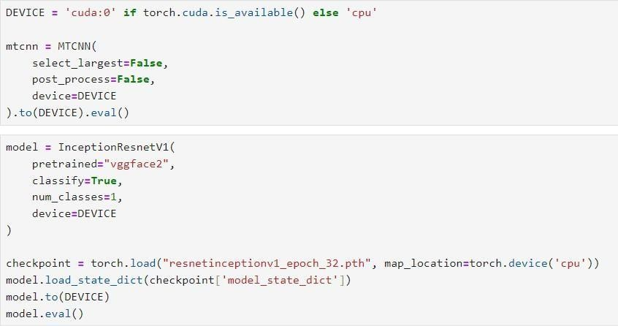**SCREENSHOTS**

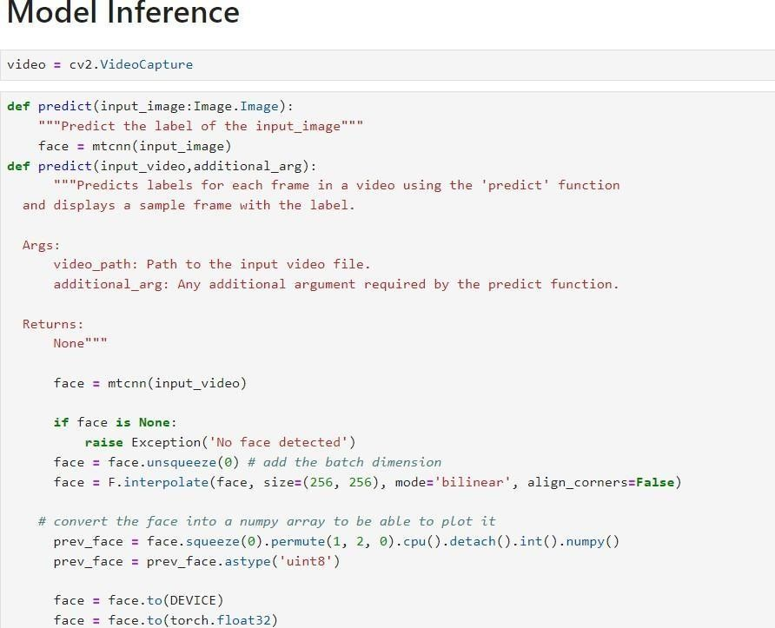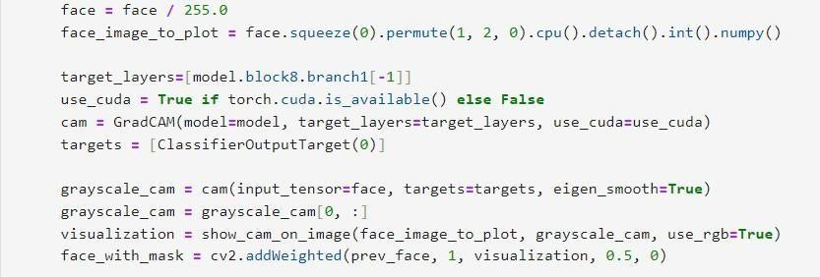

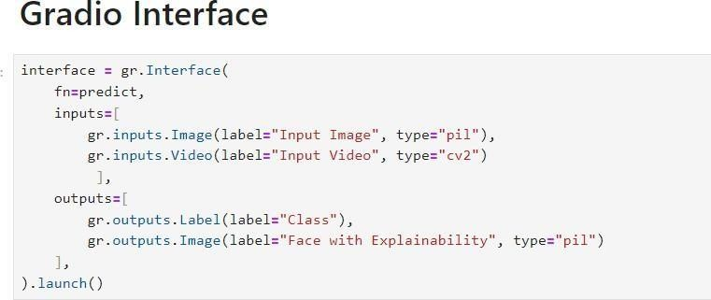



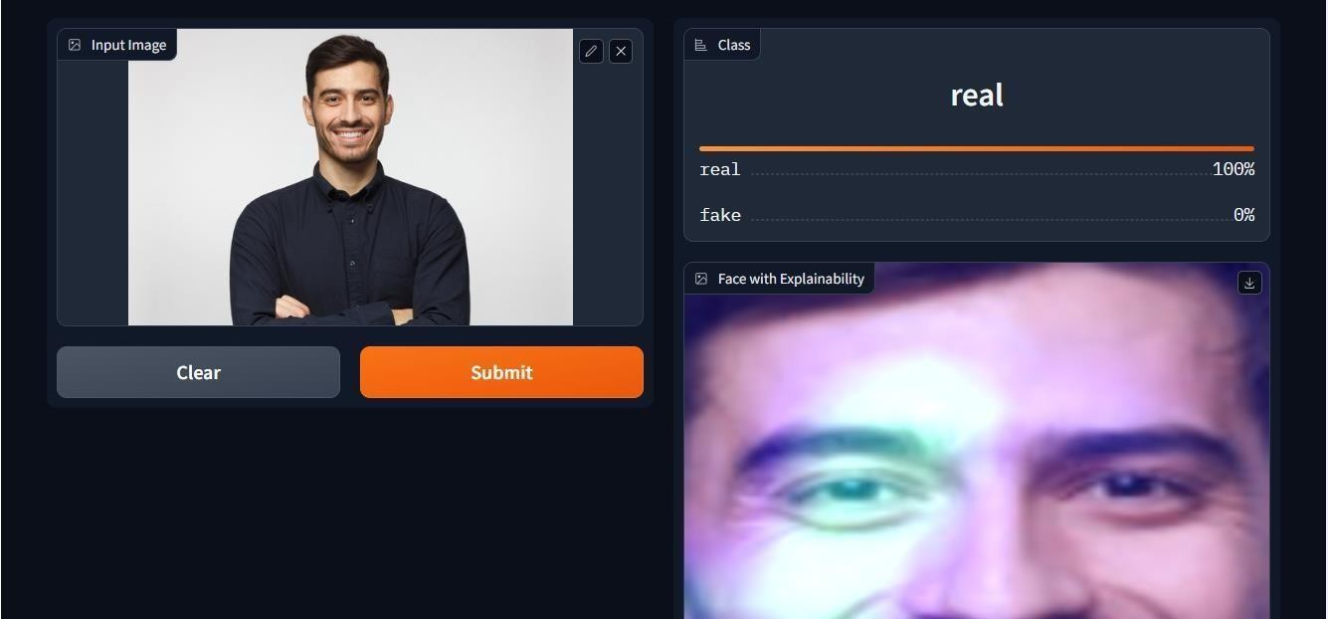

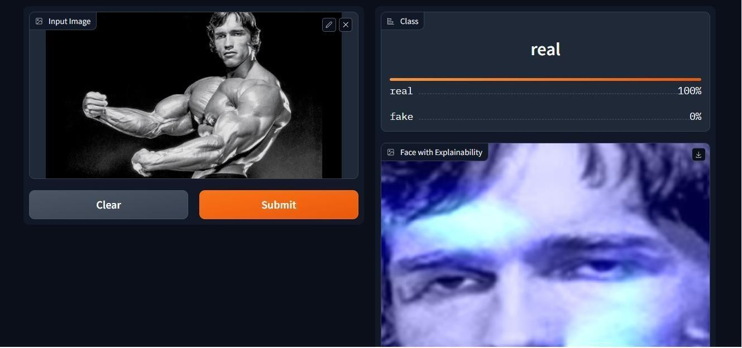

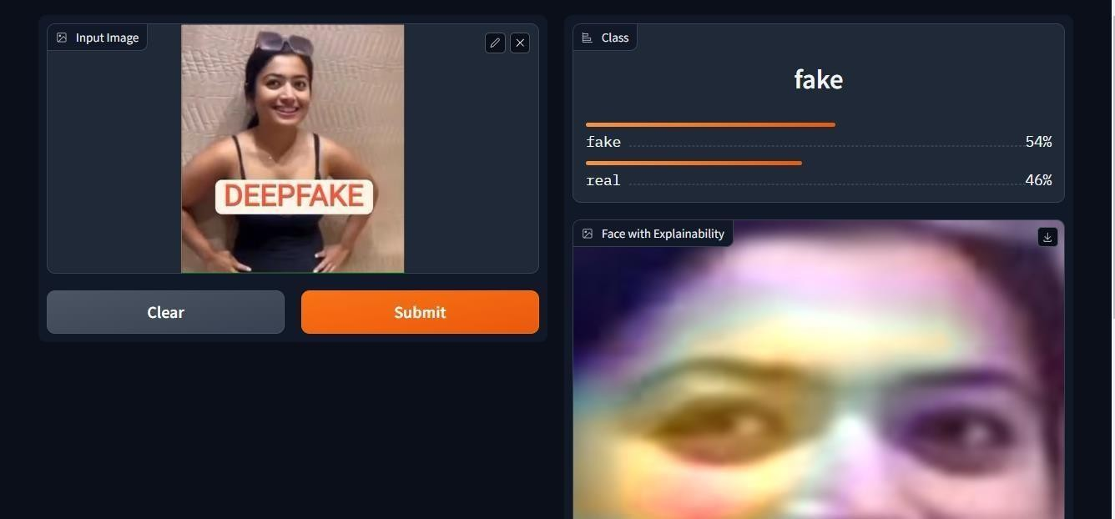

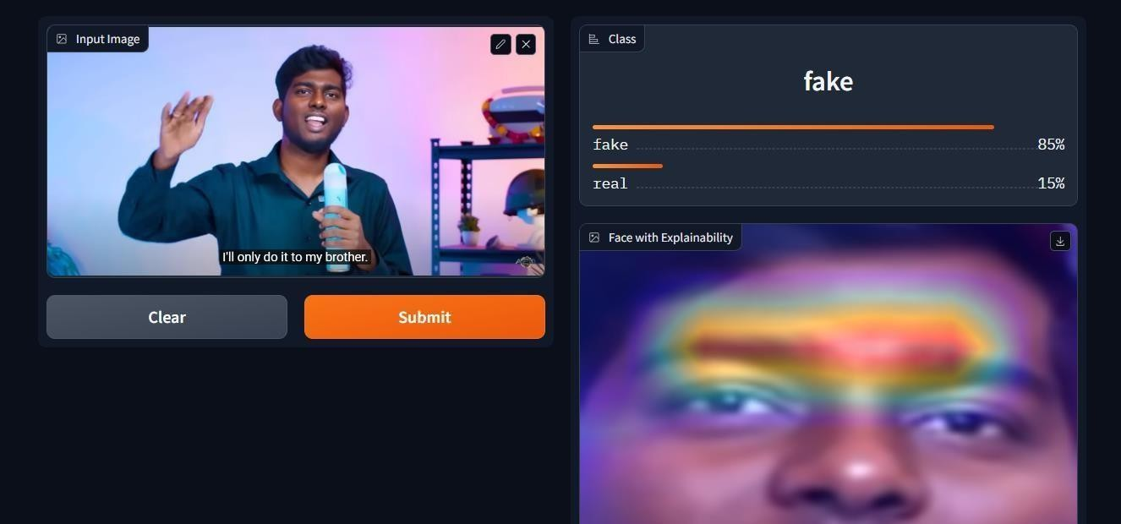

**CHAPTER-9**

**CONCLUSION & FUTURE ENHANCEMENT**

###### Conclusion

The risks of face tampering in video are well known today among most people. A number of different fields are open to us as a result of DF: advanced media, VR, mechanical technology, schooling, and many more. In another context, they represent innovations thatcan ruin and undermine the whole society.

As part of the design, we incorporated a neural network based method to classify the video as either deep fake or genuine, as well as the certainty of the proposed model. The proposedmethod is inspired by the way the deep fakes are created by the GANs with the help of Autoencoders. Using the ResNetV1 CNN, frame level detection is done, followed by video classification using the RNN and MTCNN. As a result of the listed parameters in the paper, the proposed method can identify a fake video or a real video. Analysis of our technique shows that it can reliably identify DF on the web under genuine states of dispersion, with an average of **94.63%**. There is a high expectation that real-time information will be as accurate as possible. Having the opportunity to create a solutionfor a given issue without the need for an earlier hypothetical review is a central part of profound learning. However, we also have the option to understand this arrangement's beginning to evaluate its characteristics and constraints, so we spent considerable time imagining the channels within our network. Our prominent empirical findings have shown that the eyes and mouth are integral to recognizing appearances made with DF. It is anticipated that future devices will make our organizations more powerful, efficient, and to make them better able to understand profound businesses.

###### Future Enhancement

*Model Ensembling*

By utilizing a variety of modeling algorithms or by using a variety of training data sets, ensemble modeling enables various models to predict a result. Once all of the base models are combined, an ensemble model calculates a single final prediction for the inconspicuous data. Our prediction process can be enhanced by ensembleing multiple models (ResNetV1, MesoNet, DenseNet, and Custom Model).

*Data Augmentation*

Adding augmented data to data analysis is a process that uses newly manufactured information added to previously existing data over time, or just slightly altered duplicates of data already available. It acts as a regularizer for an AI model and reduces overfitting.

*Early Stopping*

During training, early stopping can lead to better results. It enables you to specify an individual degree of training epochs and stop the preparation of a model after a certain amount of time has elapsed, enhancing a holdout validation dataset.

*BlockChain*

Researchers have found that blockchain technology can help detect deepfakes more effectively. There are not many examinations of blockchain's use in deepfake detection based on the fact that it has been used successfully in numerous fields. The ultimate tool for computerized provenance arrangement, it allows you to make an unchangeable chain of unique blocks of metadata.

*Image Aggregation*

Videos are often compressed when they are assessed, especially online videos, which can result in huge amounts of lost information. Then again, showing the same face in a succession of frames could help make the video more accurate in terms of its overall scoreif it allows for multiple experiences. The average of the network prediction over the videocan

be used to accomplish this. Theoretically, the association between frames of a single

video is so strong that a gain in scores or a confidence interval indicator can't be justified. In practice, A majority of filmed faces contain stable clear frames to give viewers comfort. A majority of good predictions on a sample of frames taken from the video suggests that the effects of movement blur, face occlusion, and random misprediction on a sample of frames are outweighed.

*Audio Manipulation*

Until now, our model only worked on deepfakes that had been manipulated on the video side. However, thanks to the rapid advancement of the CNNs [4, 20], the Generative Adversarial Networks (GANs), and their variants, it is now possible to create deepfakes that have been manipulated on the audio side as well. Video with manipulated audio will be declared fake, but the faces will remain genuine, This makes it much more difficult to distinguish true, untampered audiovisuals from those that have been altered. Due to the ability to create a sound, video, and images that appear real, various stakeholders have taken action to deter such developments from being used maliciously. Consequently, researchers are attempting to devise deepfake detection mechanisms that can also detect synthesized audio.

###### Applications

* Fake News Detection
* Prevent damage to reputation of individuals
* Malicious hoaxes detection
* Prevent distortion of democratic discourse
* Reduces exacerbation of social divisions
* Prevents Financial Fraud

**10 REFERENCES**

1. Joshua Brockschmidt, Jiacheng Shang, and Jie Wu. On the Generality of Facial Forgery Detection. In *2019 IEEE 16th International Conference on Mobile Ad Hoc and Sensor Systems Workshops (MASSW)*, pages 43–47. IEEE, 2019.
2. Yuezun Li, Ming-Ching Chang, and Siwei Lyu. In Ictu Oculi: Exposing AI Generated Fake Face Videos by Detecting Eye Blinking. *arXiv preprint arXiv:1806.02877v2*, 2018.
3. TackHyun Jung, SangWon Kim, and KeeCheon Kim. Deep-Vision: Deepfakes Detection Using Human Eye Blinking Pattern. *IEEE Access*, 8:83144–83154, 2020.
4. Konstantinos Vougioukas, Stavros Petridis, and Maja Pantic. Realistic Speech-Driven Facial Animation with GANs. *International Journal of Computer Vision*, 128:1398–1413, 2020.
5. Hai X. Pham, Yuting Wang, and Vladimir Pavlovic. Generative Adversarial Talking Head: Bringing Portraits to Life with a Weakly Supervised Neural Network. *arXiv preprint arXiv:1803.07716*, 2018.
6. Yuezun Li, Siwei Lyu, “ExposingDF Videos By Detecting Face Warping Artifacts,” in arXiv:1811.00656v3.
7. Yuezun Li, Ming-Ching Chang and Siwei Lyu “Exposing AI Created Fake Videos by DetectingEye Blinking” in arxiv.
8. Huy H. Nguyen , Junichi Yamagishi, and Isao Echizen “ Using capsule networks to detect forged images and videos ”.
9. Umur Aybars Ciftci, ˙Ilke Demir, Lijun Yin “Detection of Synthetic Portrait Videos using Biological Signals” in arXiv:1901.02212v2.
10. <https://www.kaggle.com/c/deepfake-detection-challenge/data>
11. Liu, M. Y., Huang, X., Mallya, A., Karras, T., Aila, T., Lehtinen, J., and Kautz, J. (2019). Few-shot unsupervised image-to-image translation. In Proceedings of the IEEE International Conference on Computer Vision (pp. 10551-10560).
12. Park, T., Liu, M. Y., Wang, T. C., and Zhu, J. Y. (2019). Semantic image synthesis with spatially adaptive normalization. In Proceedings of the IEEE Conference on Computer Vision andPattern Recognition (pp. 2337-2346).
13. DeepFaceLab: Explained and usage tutorial. Available at https://mrdeepfakes.com/forums/thread-deepfacelab-explained-and-usage-tutorial.
14. DSSIM. Available at [https://github.com/keras-](https://github.com/keras-team/keras-) [team/keras-](https://github.com/keras-team/keras-)contrib/blob/master/keras_contrib/losses/dssim.py.
15. Lattas, A., Moschoglou, S., Gecer, B., Ploumpis, S., Triantafyllou, V., Ghosh, A., & Zafeiriou,

S. (2020). AvatarMe: realistically renderable 3D facial reconstruction “in-the-wild”. In Proceedings of the IEEE/CVF Conference on Computer Vision and Pattern Recognition (pp. 760-769).

1. Ha, S., Kersner, M., Kim, B., Seo, S., & Kim, D. (2020, April). MarioNETte: few-shot face reenactment preserving identity of unseen targets. In Proceedings of the AAAI Conference on Artificial Intelligence (vol. 34, no. 07, pp. 10893-10900).
2. Deng, Y., Yang, J., Chen, D., Wen, F., & Tong, X.(2020). Disentangled and controllable faceimage generationvia 3D imitative-contrastive learning. In Proceedings of the IEEE/CVF Conference on Computer Vision and Pattern Recognition (pp. 5154-5163).
3. Tewari, A., Elgharib, M., Bharaj, G., Bernard, F., Seidel, H. P., P´erez, P., ... & Theobalt, C. (2020). StyleRig: Rigging StyleGAN for 3D control over portrait images. In Proceedings of the IEEE/CVF Conference on Computer Vision and Pattern Recognition (pp. 6142-6151).
4. Li, L., Bao, J., Yang, H., Chen, D., & Wen, F. (2019). FaceShifter: Towards high fidelity andocclusion aware face swapping. arXiv preprint arXiv:1912.13457.
5. Nirkin, Y., Keller, Y., & Hassner, T. (2019). FSGAN: subject agnostic face swapping and reenactment. In Proceedings of the IEEE/CVF International Conference on Computer Vision (pp.7184-7193).
6. Olszewski, K., Tulyakov, S., Woodford, O., Li, H., & Luo, L. (2019). Transformable bottleneck networks. In Proceedings of the IEEE/CVF International Conference on Computer Vision (pp. 7648-7657).
7. Chan, C., Ginosar, S., Zhou, T., & Efros, A. A. (2019). Everybody dances now. In Proceedingsof the IEEE/CVF International Conference on Computer Vision (pp. 5933-5942).
8. Thies, J., Elgharib, M., Tewari, A., Theobalt, C., & Nießner, M. (2020, August). Neural voicepuppetry: Audio-driven facial reenactment. In European Conference on Computer Vision (pp. 716-731). Springer, Cham.